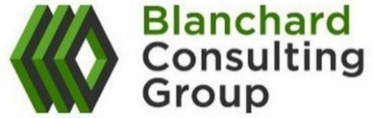
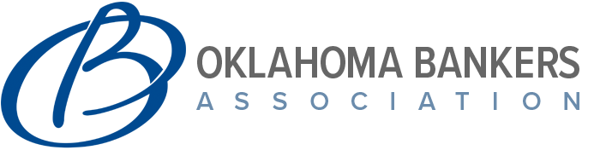
2022 Salary and Cash Compensation Survey

Contact Laura Roth at surveys@blanchardc.com or 612-850-0153 for details

Survey highlights:
- Open for participation! Deadline to participate is Friday, July 1st.
- 207 participants in the 2021 Salary and Cash Compensation Survey (12 from Oklahoma)
- Contains salary and cash compensation (salary + annual cash incentive/bonus) data for approximately 25 executive positions and over 150 middle management and staff level positions
- Summarizes actual cash bonuses paid for 2021 performance as a percent of salary as well as the potential earning opportunity under a performance-based cash incentive plan at target and maximum performance, where available
- Pricing for the 2022 Salary and Cash Compensation Survey Results
  - OBA Member & Participant: $300
  - OBA Member & Non-Participant: $600
  - Non-OBA Member & Non-Participant: $800

Other Available Surveys:
- 2021 Mortgage Loan Officer Incentive Design and Pay Practices Survey
  - 72 Banks (available for purchase)
- 2021 Director Compensation Survey
  - 112 Banks (available for purchase)

For more information about Blanchard Consulting Group visit us at:
WWW.BLANCHARDC.COM

