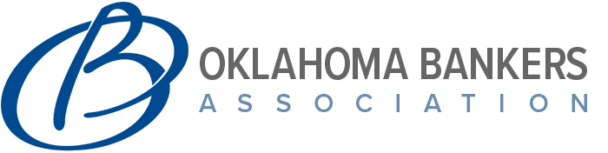
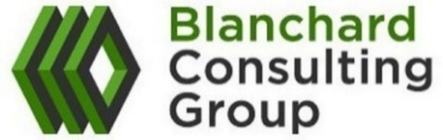
2022 Compensation Trends & Employee Benefits Survey

Contact Laura Roth at surveys@blanchardc.com or 612-850-0153 for details

Surveys highlights:
- 140 participants in the 2020 Compensation Trends & Employee Benefits Survey.
- Covers recent trends in various compensation programs such as: annual incentive plan design and payouts, equity/long-term incentive programs, executive benefits (including employment/change-in-control agreements), deferred compensation plans/supplemental executive retirement plans, and perquisites.
- Includes information on employee benefits surrounding 401K plans, tuition reimbursements, medical coverage, and more.
- Pricing for the 2022 Compensation Trends & Employee Benefits Survey Results
  - OBA Member & Participant: $150
  - OBA Member & Non-Participant: $300
  - OBA Member & Non-Bank/Non-Participant: $600

Surveys Available for Purchase:
- 2021 Salary and Cash Compensation Survey
  - 207 Bank Participants
  - Includes approximately 20 executive and 150 middle management/staff level positions
- 2021 Director Compensation Survey
  - 112 Bank Participants
  - Customized Board Compensation Analysis (available for purchase as a supplement)

Coming This Spring/early summer:
***2022 salary and cash compensation survey***
For more information about Blanchard Consulting Group visit us at:
WWW.BLANCHARDC.COM

